**Simple end to end scenario for File to RFC in SAP PI**

1. Login into EC5 system and go to tcode SE11, create a table called ZDEMO_ITEMS with the relevant fields and activate it.

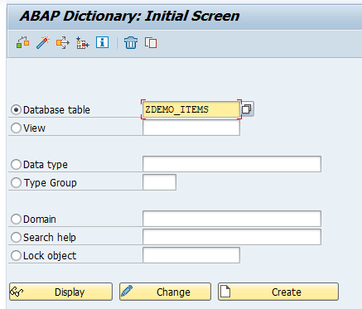

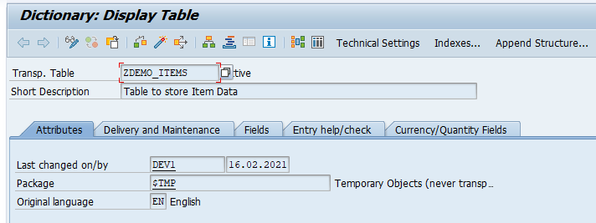

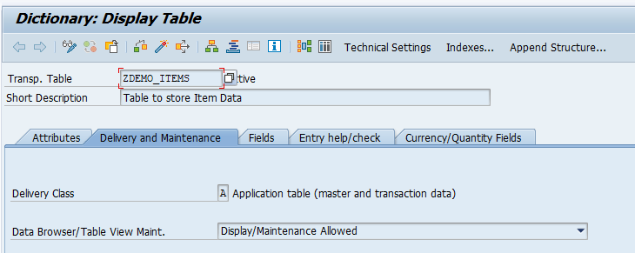

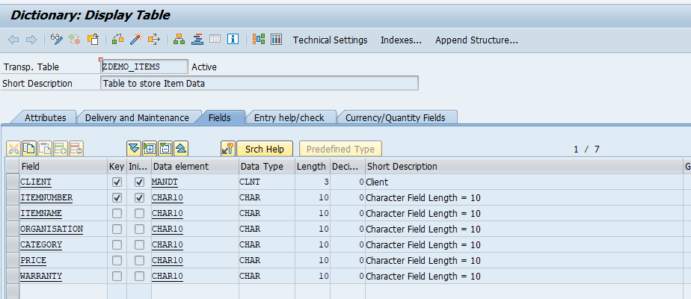

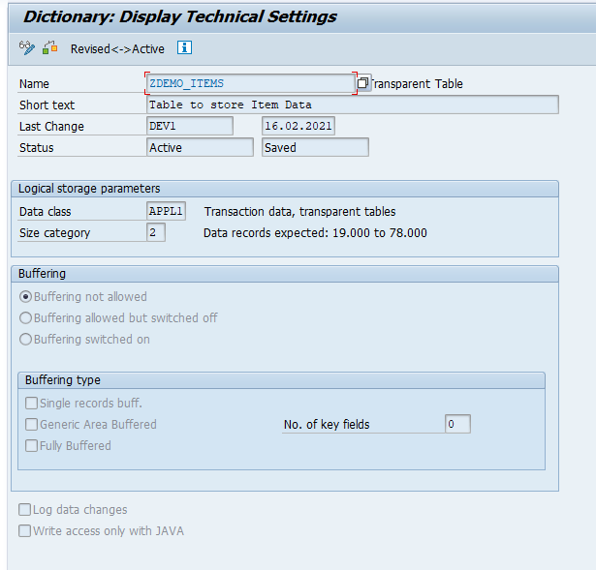

1. Go to tcode SE37 and create a FM called ZDEMO_UPDATEITEMS with an appropriate function group or create a new one, provide proper import and export parameters then write the source code and activate it.

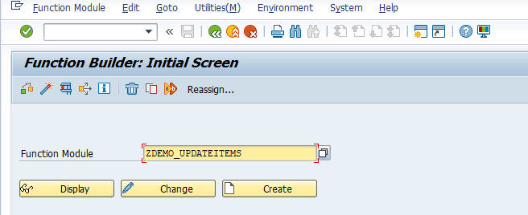

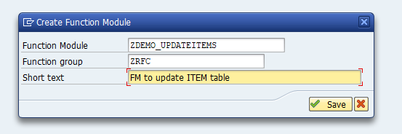

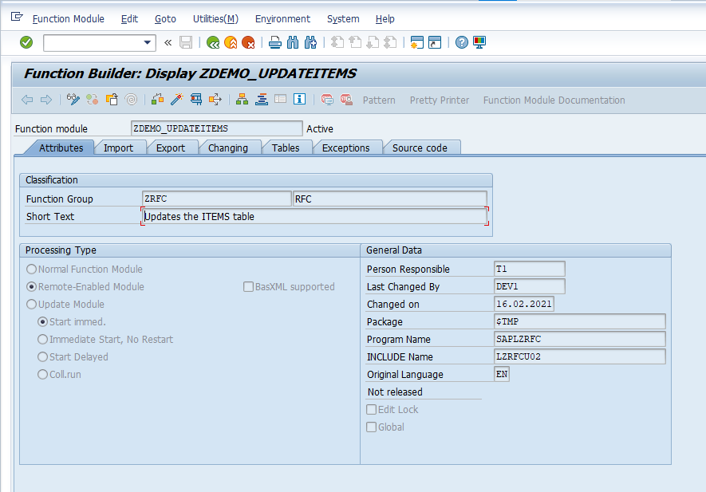

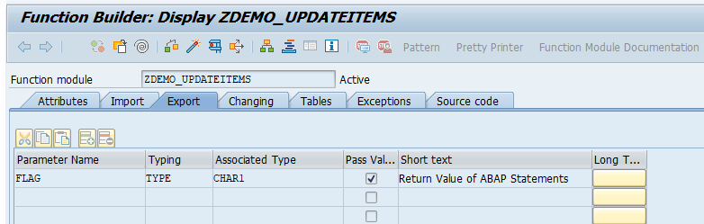

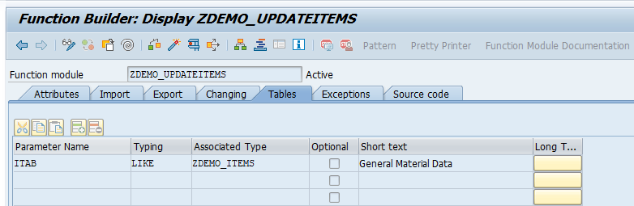

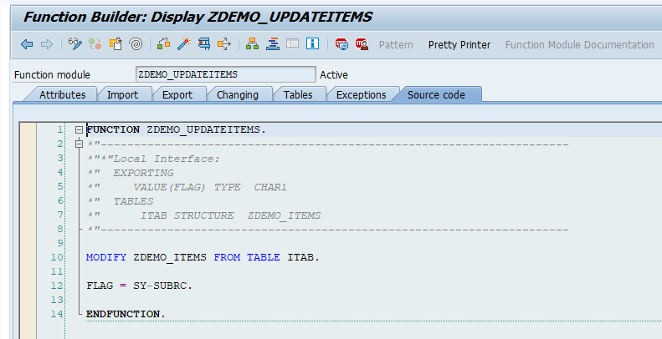

1. Login to ESR of XI1 system. Import the FM ZDEMO_UPDATEITEMS created in EC5 system under imported objects of SCW CG_GENNEXT_2021, 1.0 of capgemini.com.

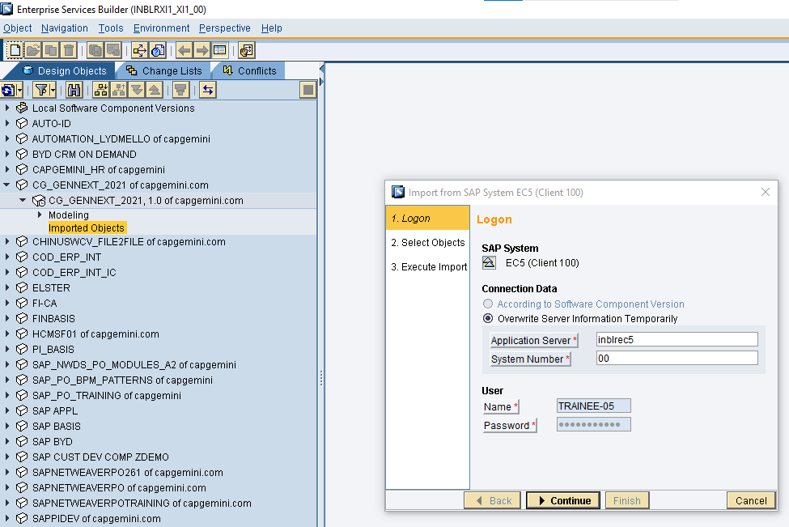

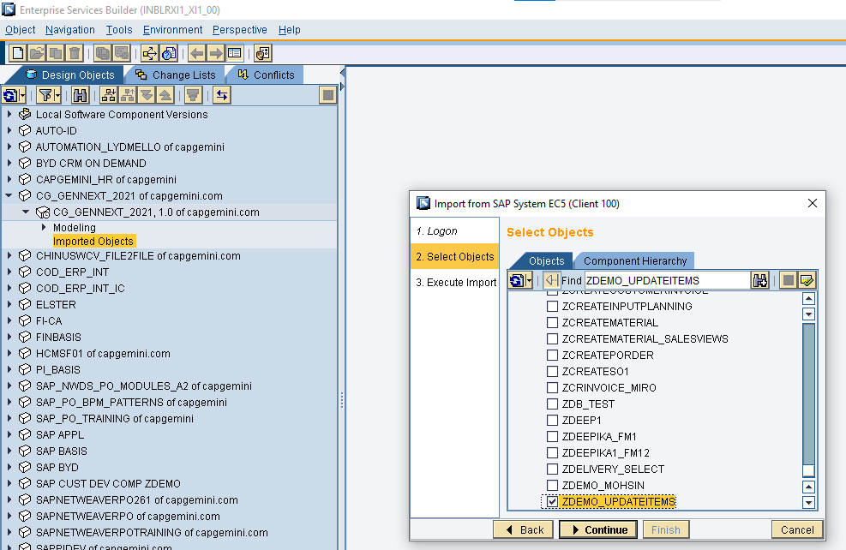

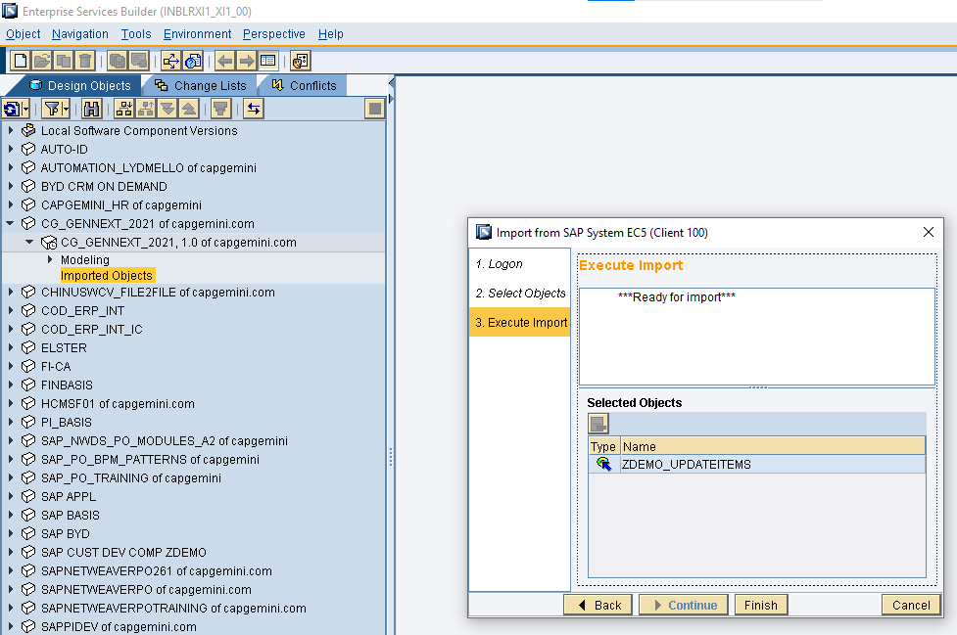

1. Create your own namespace if not already created under SCW CG_GENNEXT_2021, 1.0 of capgemini.com.

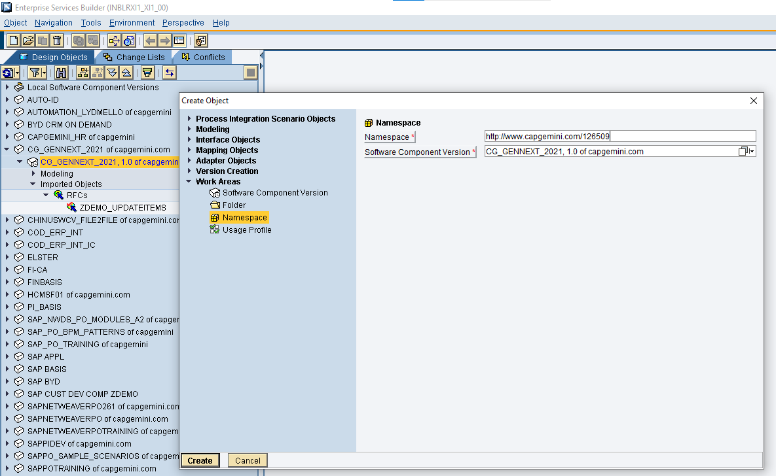

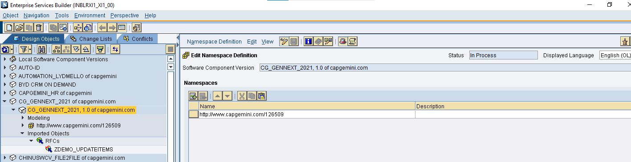

1. Create data type DT_Product.

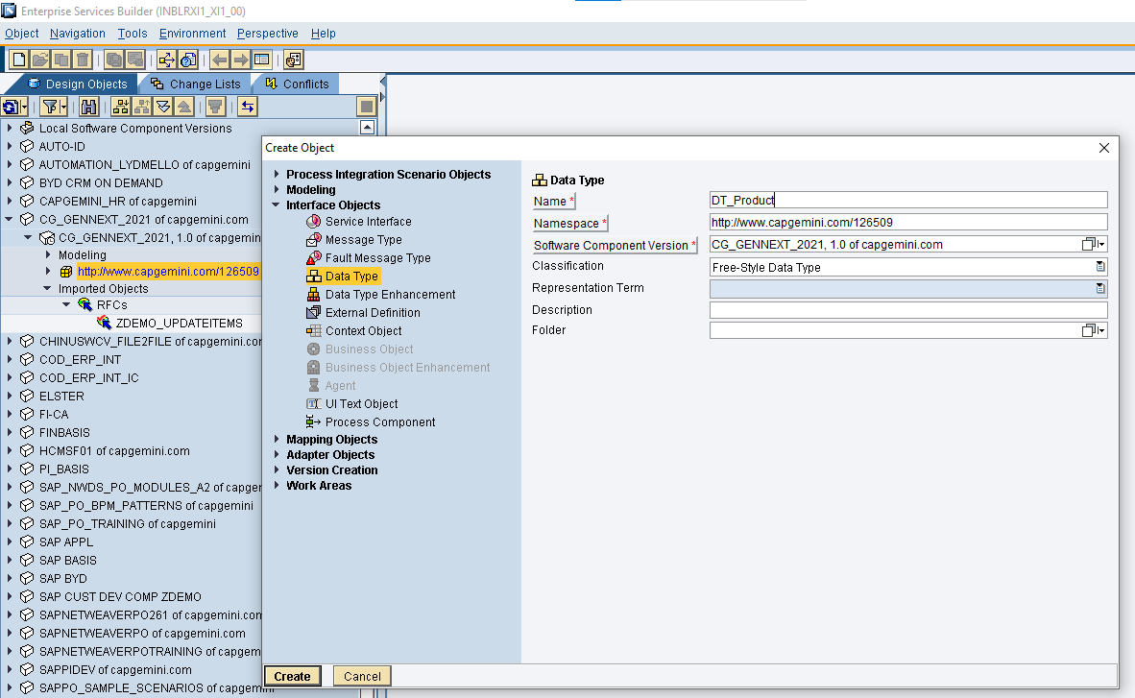

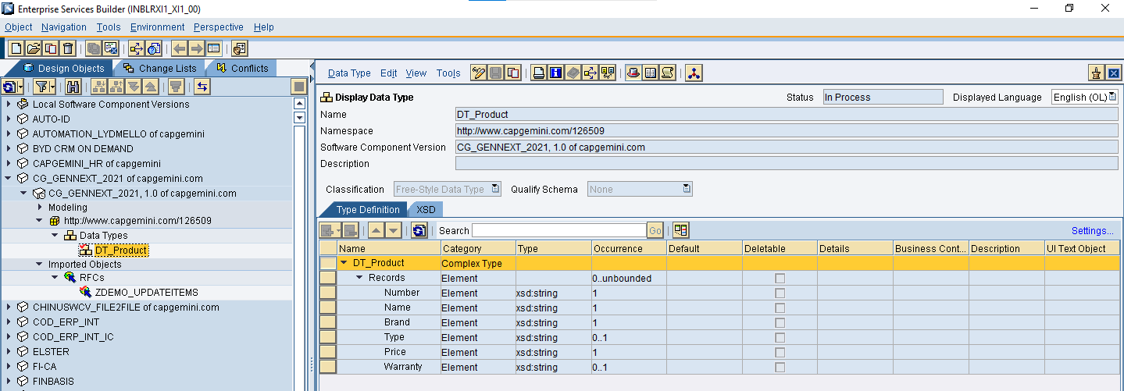

1. Create message type MT_Product.

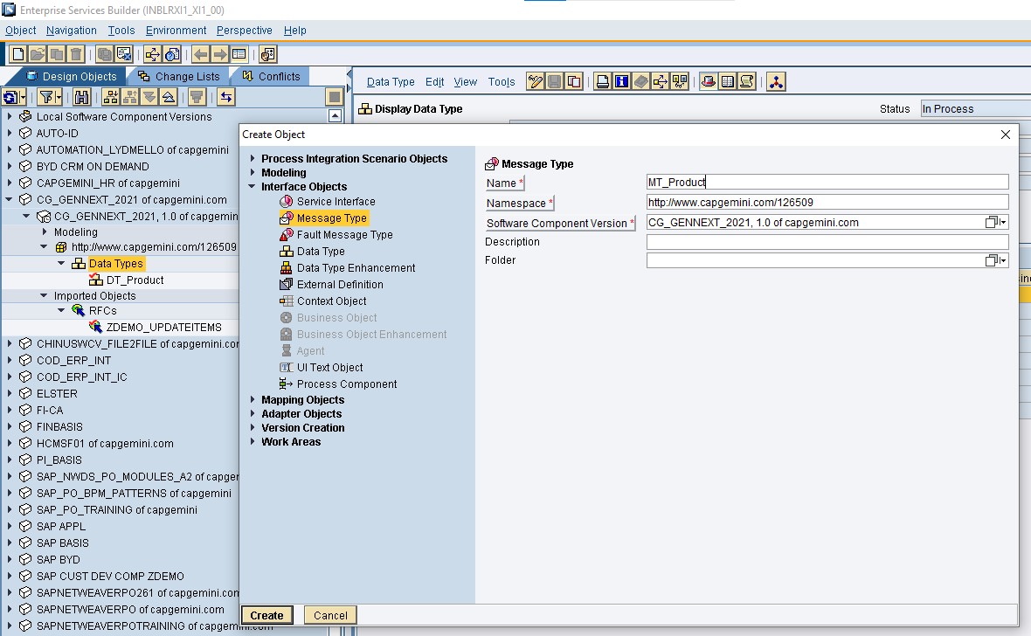

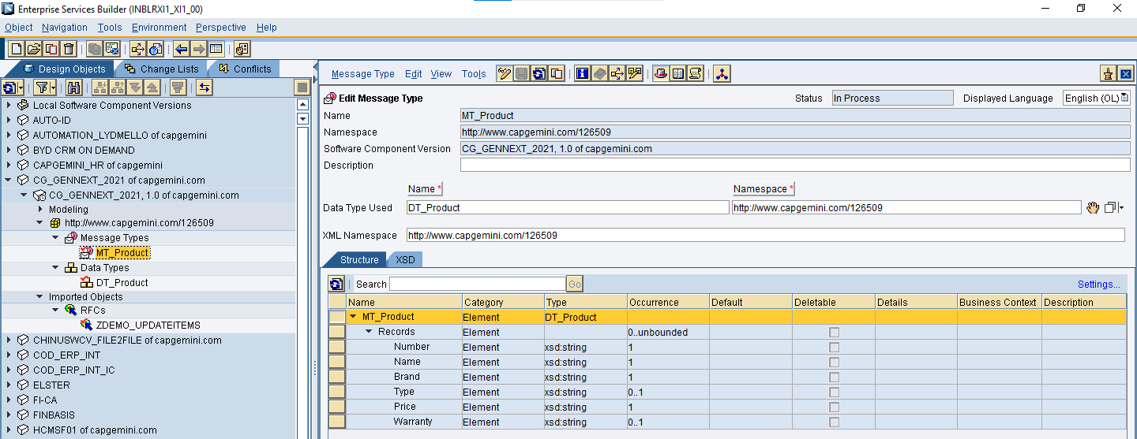

1. Create outbound asynchronous service interface SI_Product_File_Out with message type MT_Product.

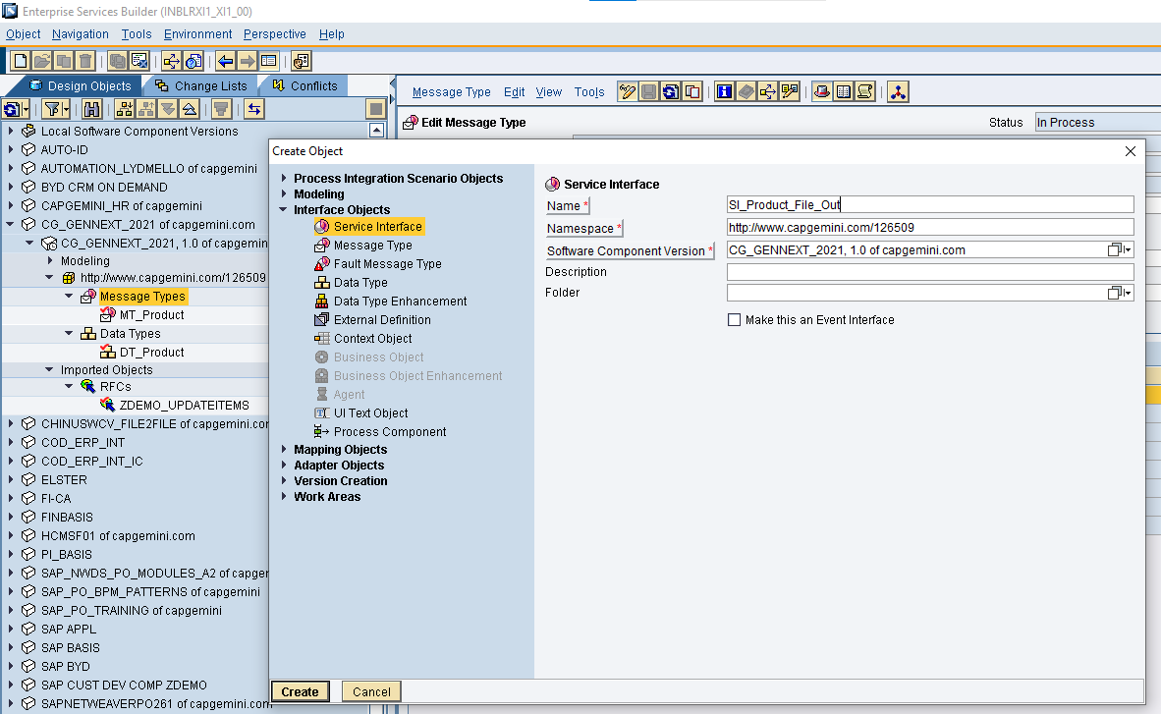

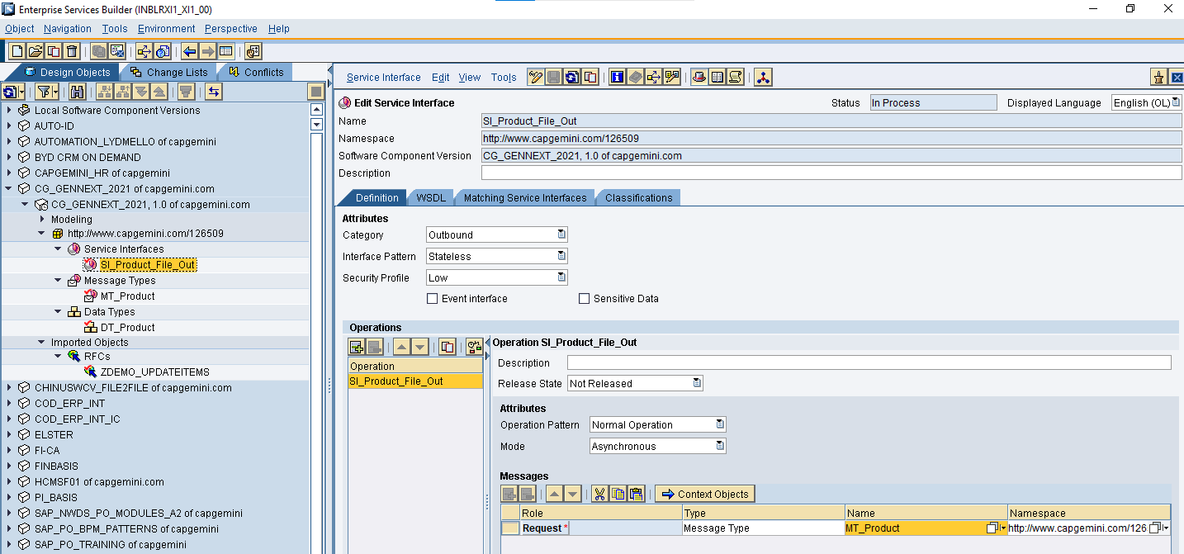

1. Create inbound asynchronous service interface SI_Item_RFC_In with RFC message type ZDEMO_UPDATEITEMS.

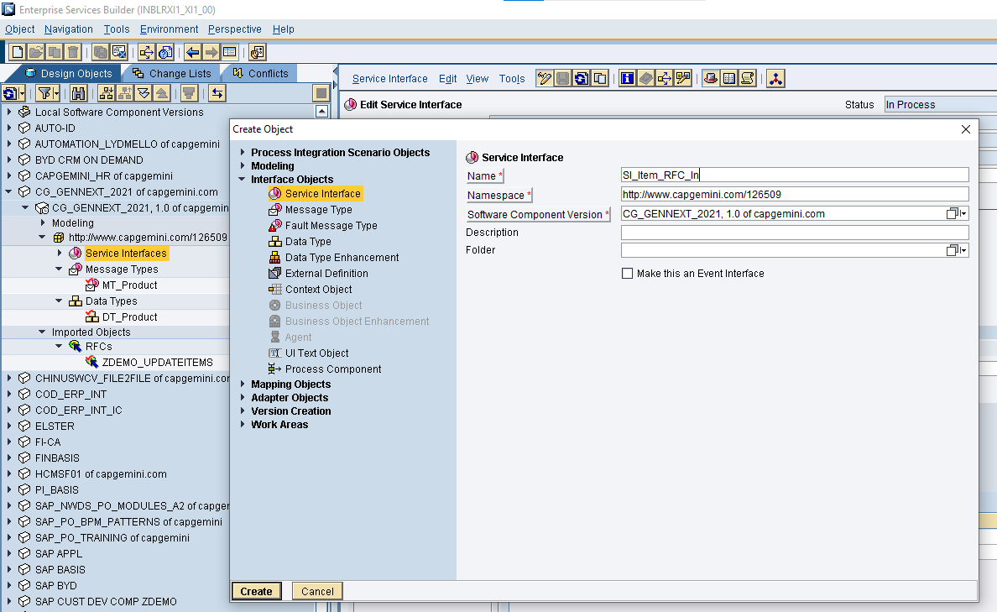

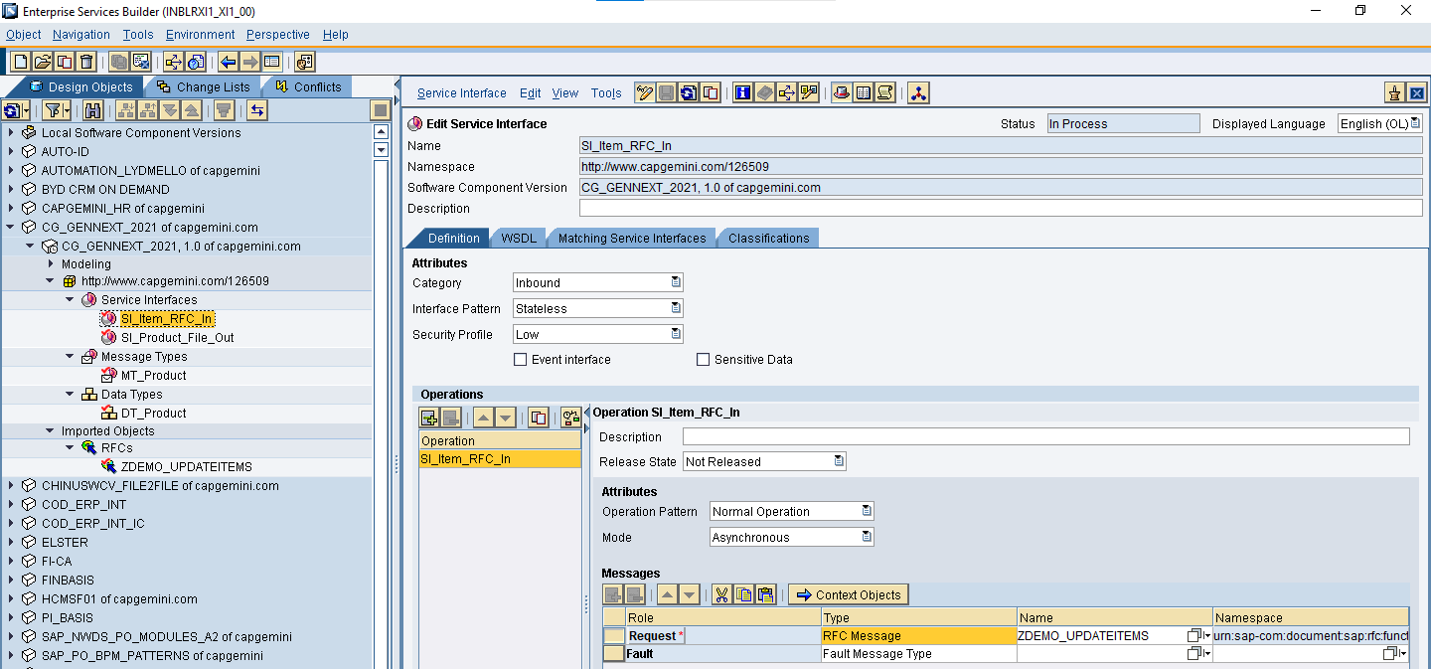

1. Create message mapping MM_Product_To_Item and provide one to one mapping between the relevant fields.

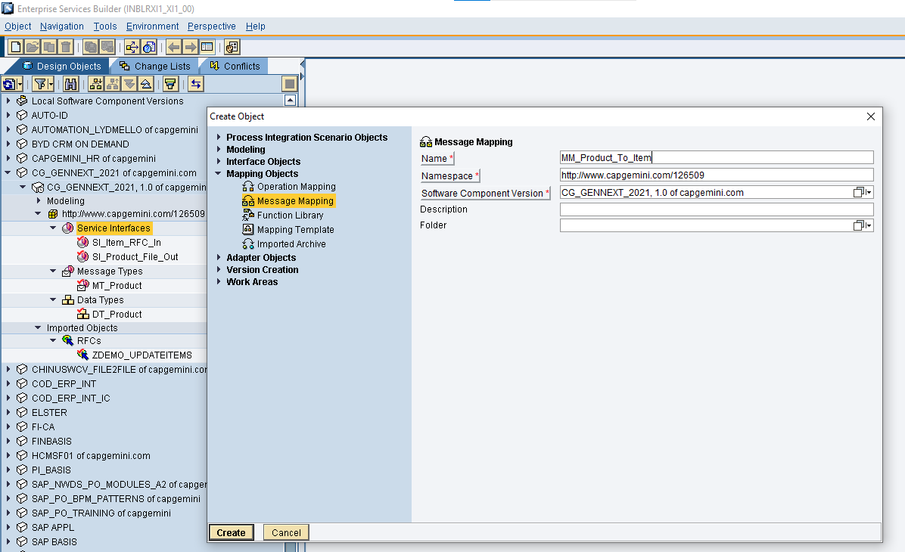

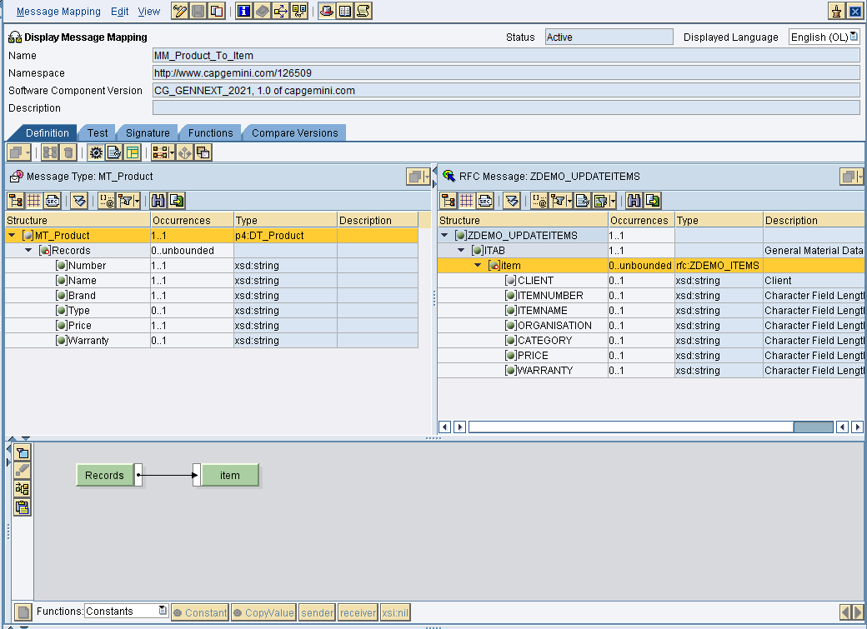

1. Create operation mapping OM_Product_To_Item with relevant service interfaces and message mapping.

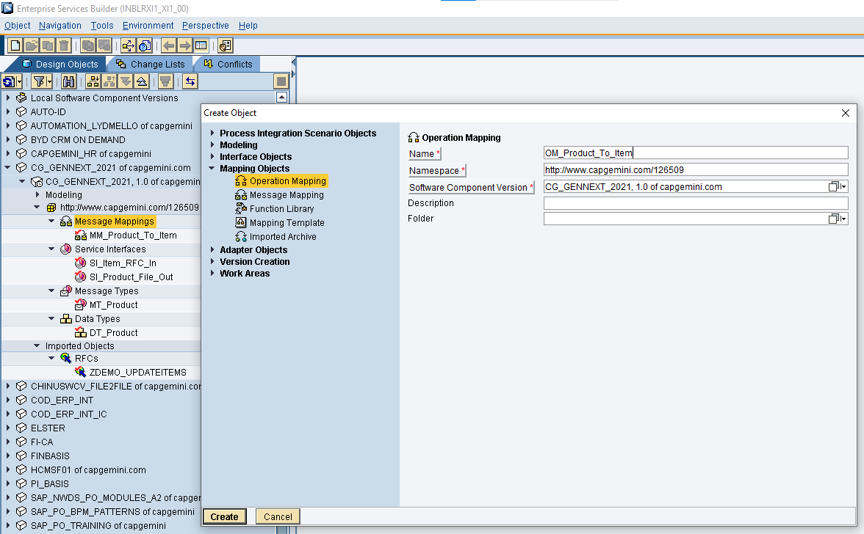

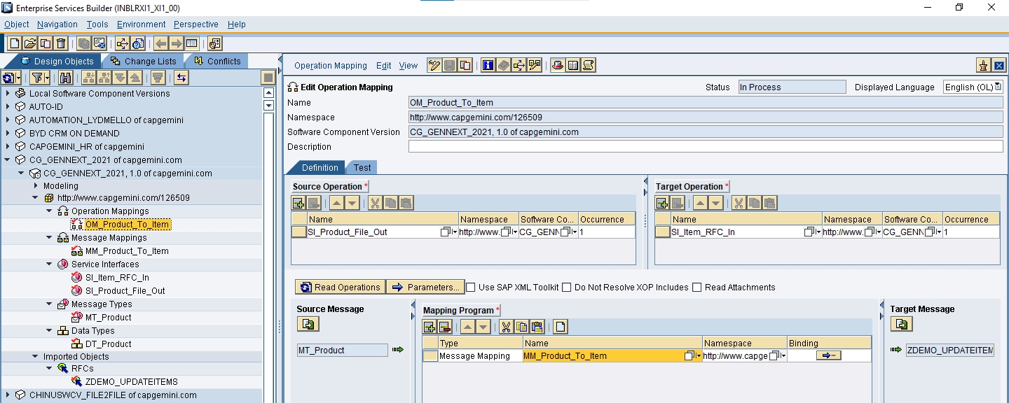

1. Finally activate all the objects.

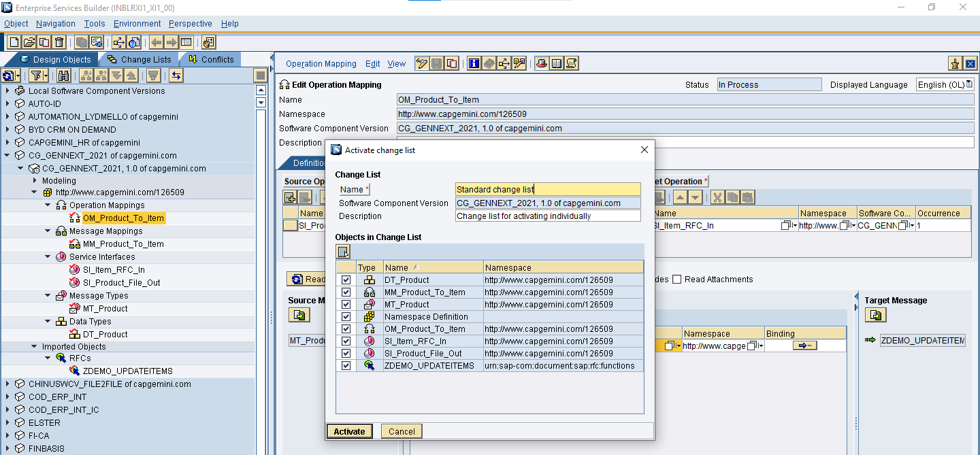

1. Login to ID of XI1 system. Create a configuration scenario CS_<your employee id>_FileToRFC.

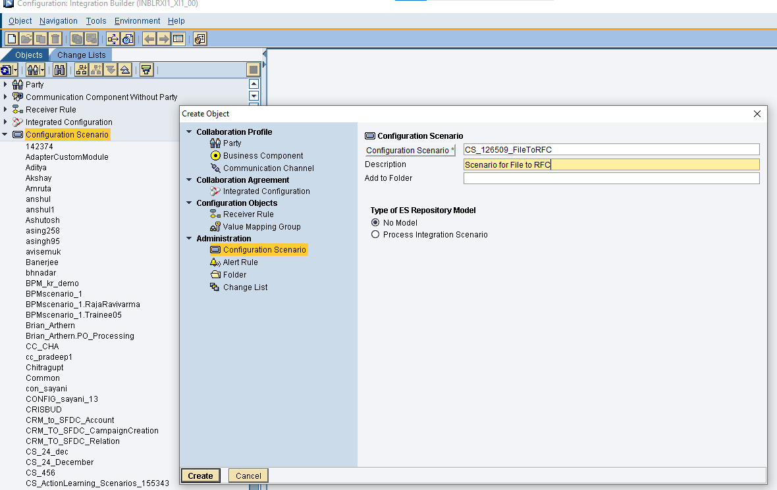

1. Import the sender Business Component BC_Training_Demo and receiver Business System BS_EC5CLNT100.

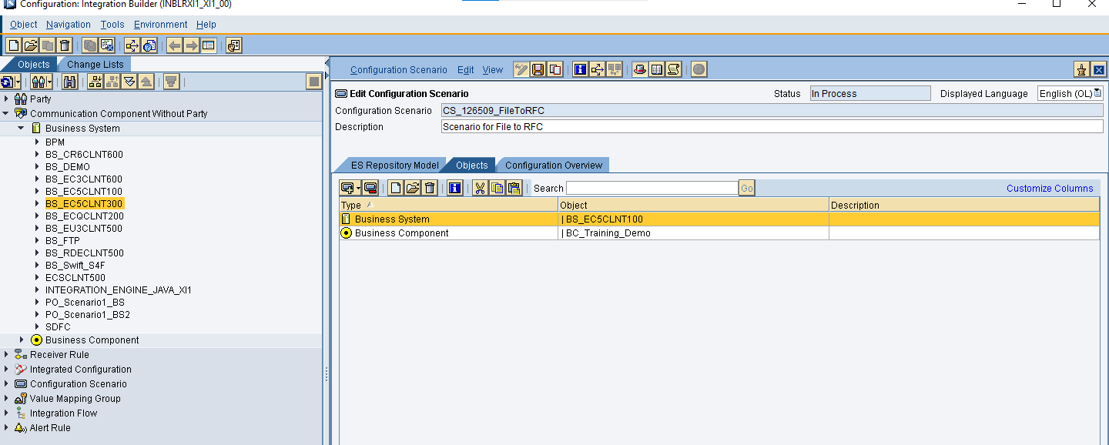

1. Create the file sender communication channel with the directory path \\inblrxi1\Training\Capgemini_2021\Out and file name as InputXML.xml, also provide the archive path as \\inblrxi1\Training\Capgemini_2021\Archive.

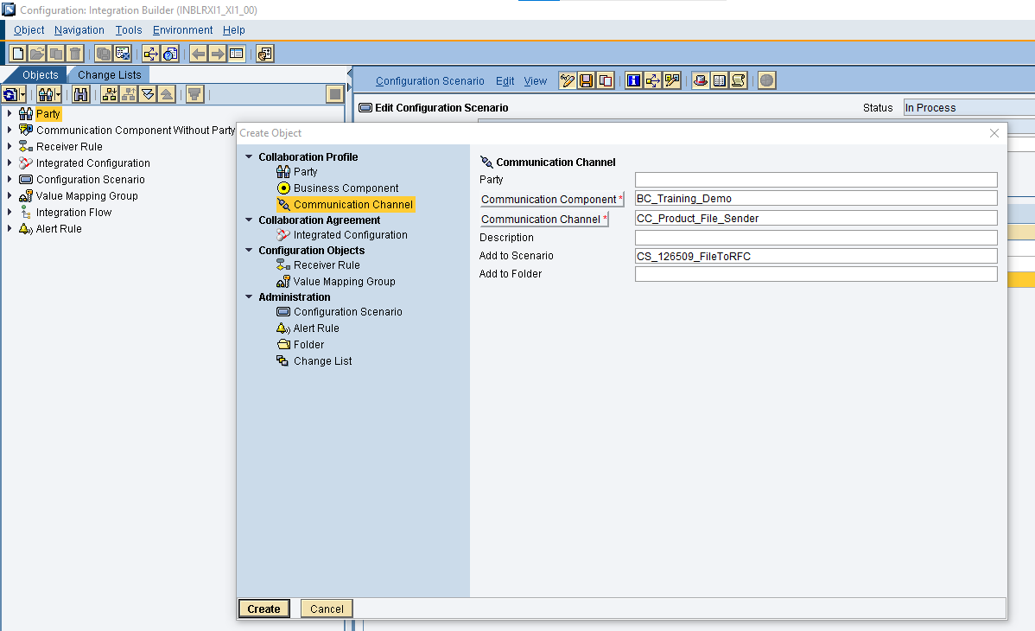

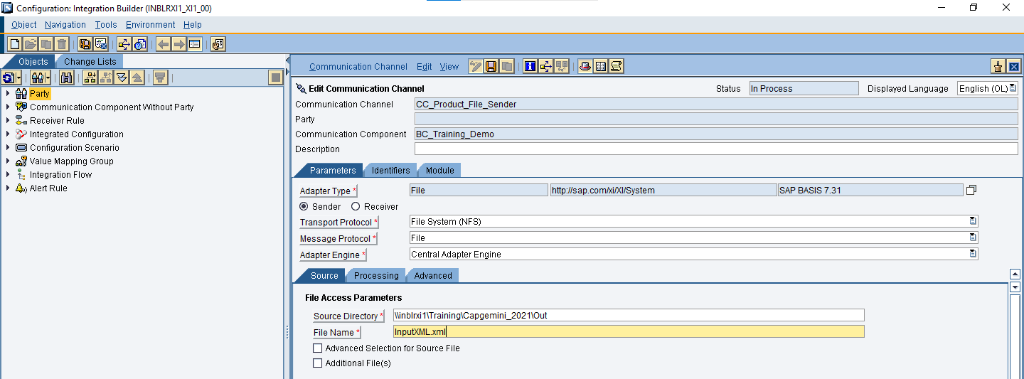

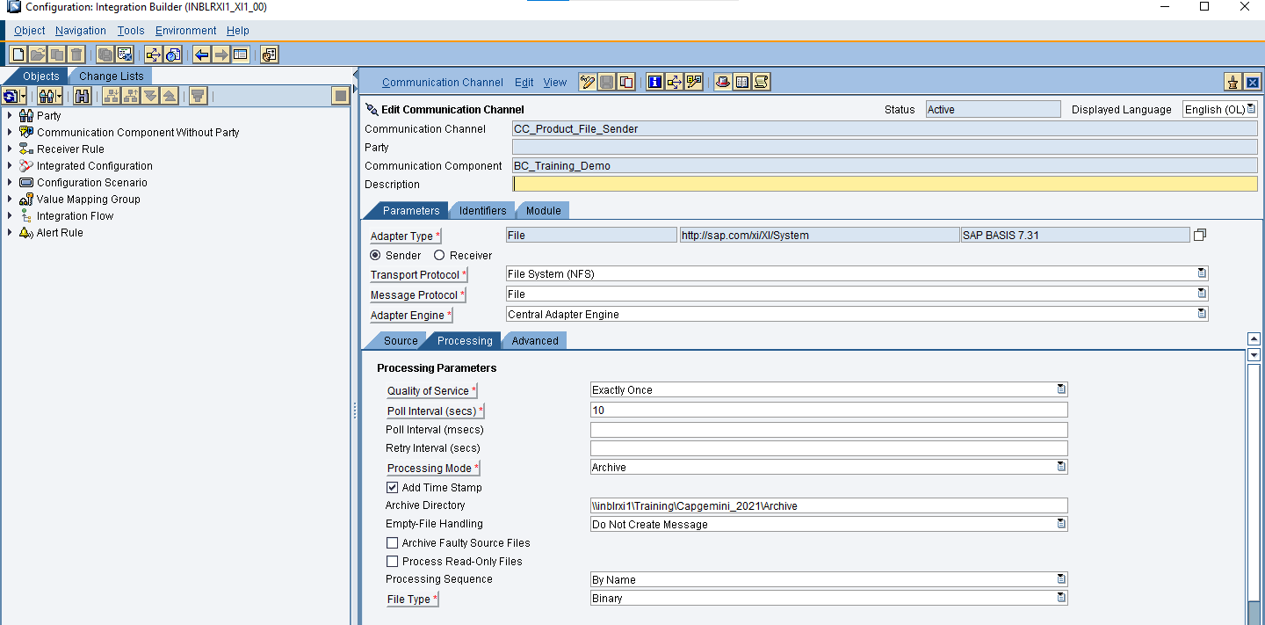

1. Create the RFC receiver communication channel and provide system details and login credentials.

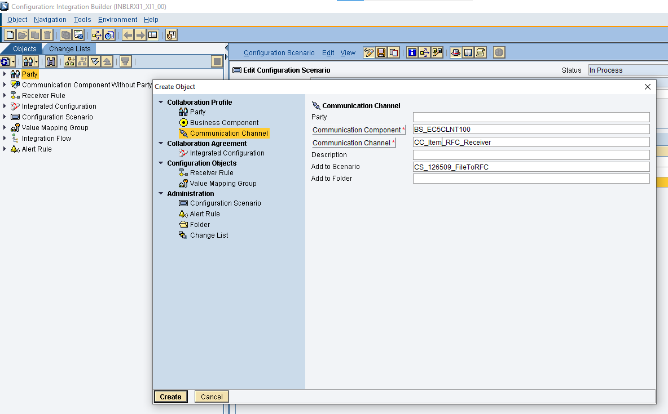

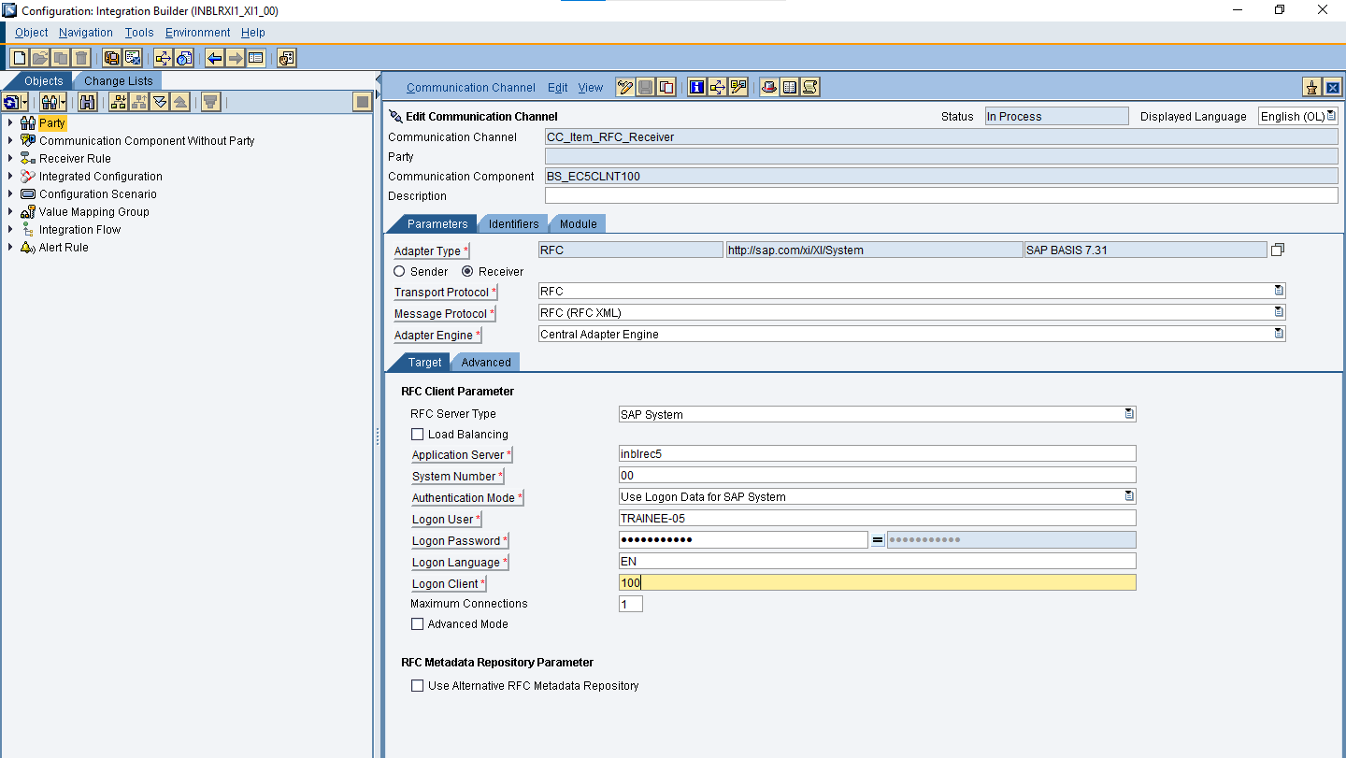

1. Create an Integrated Configuration (ICO) and provide the relevant channels, receiver and operation mapping.

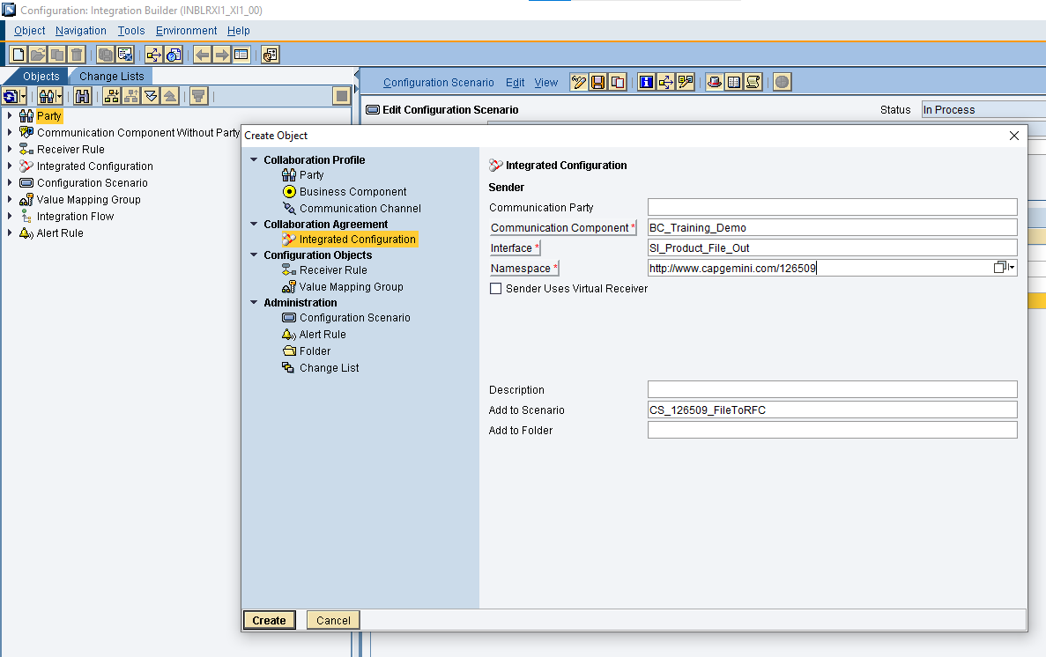

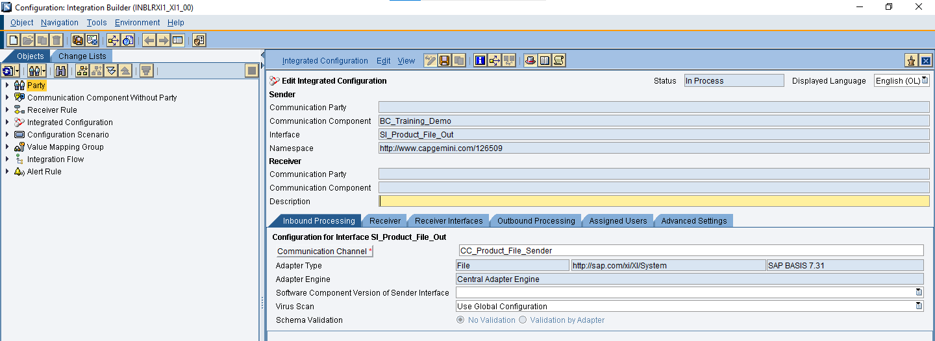

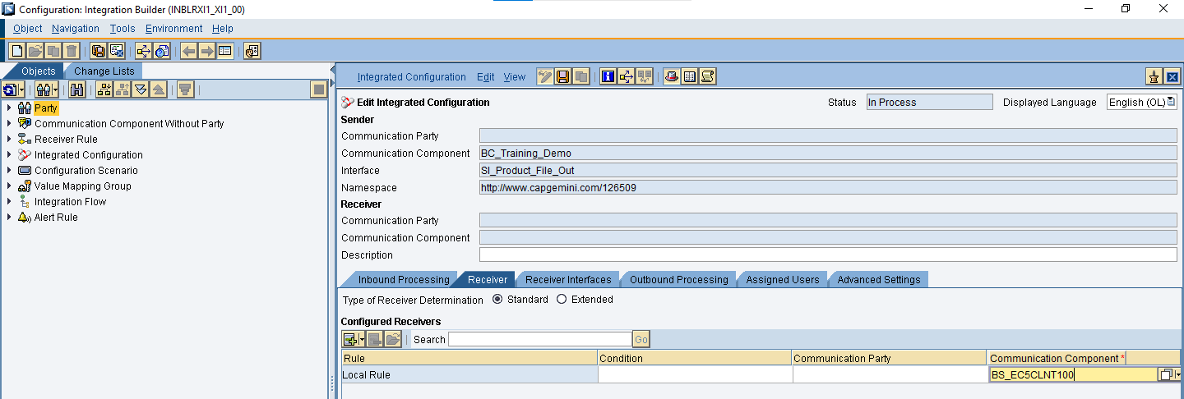

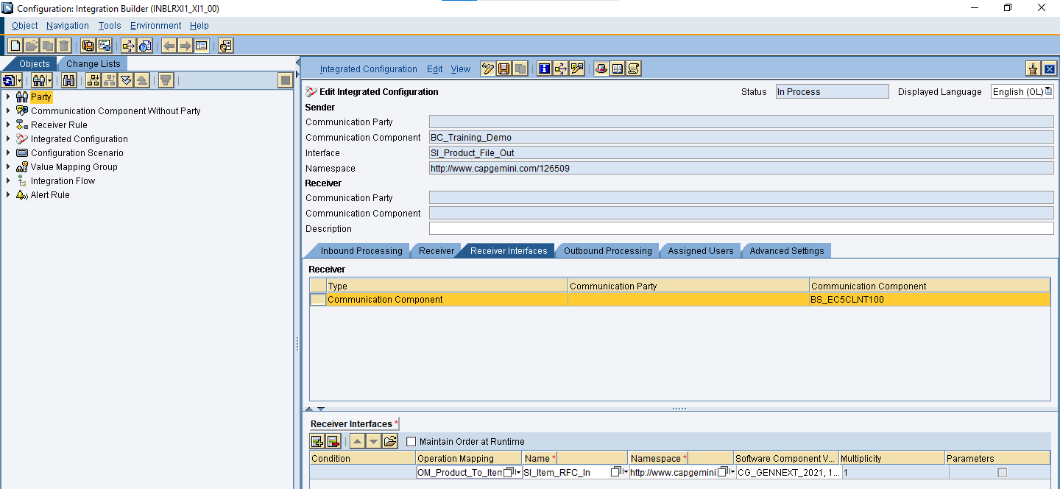

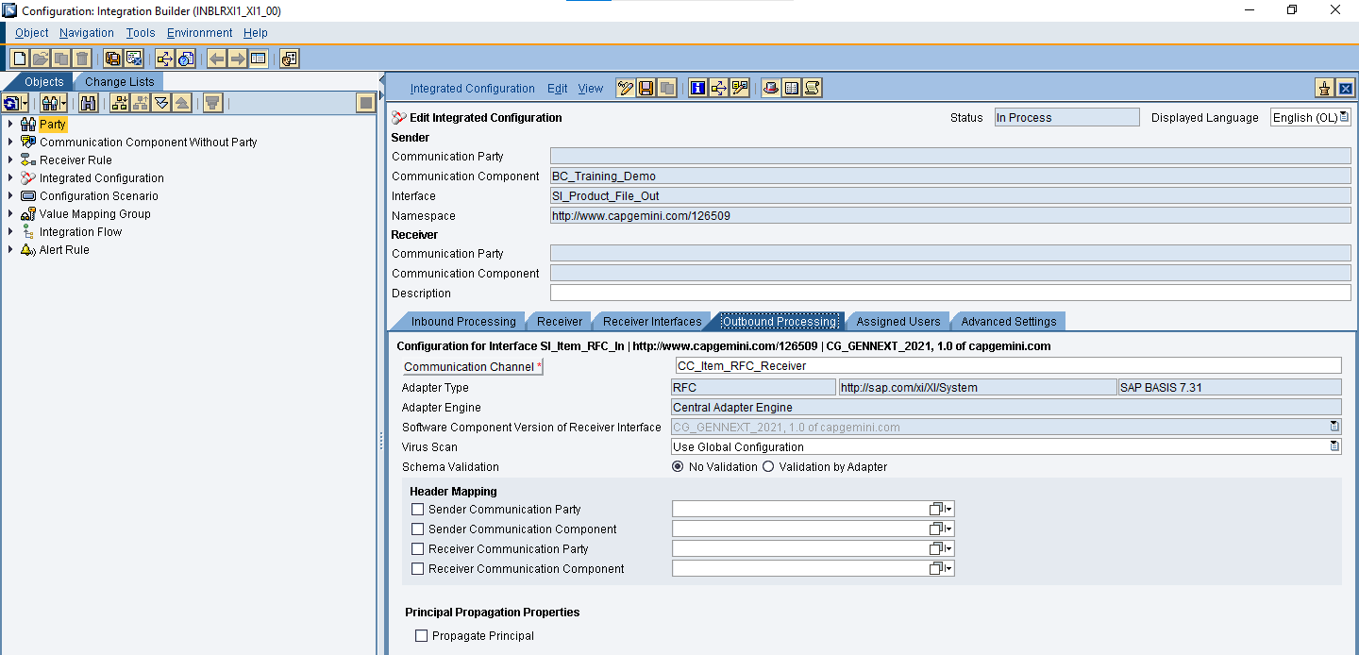

1. Activate all the objects.

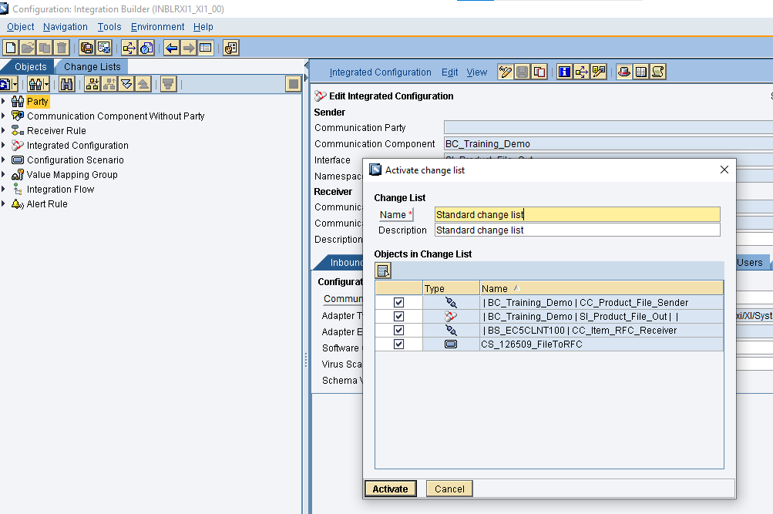

1. InputXML.xml placed in the source directory \\inblrxi1\Training\Capgemini_2021\Out gets picked up by PI and archived in the Archive folder \\inblrxi1\Training\Capgemini_2021\Archive.

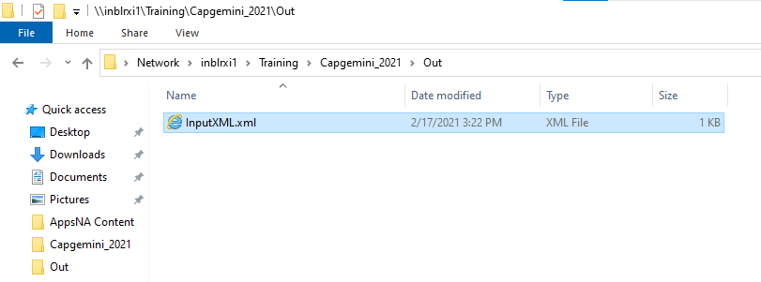

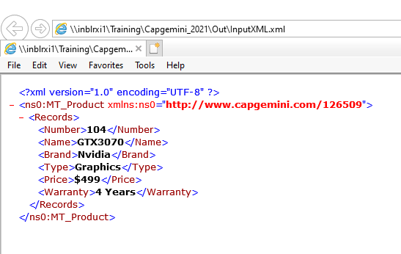

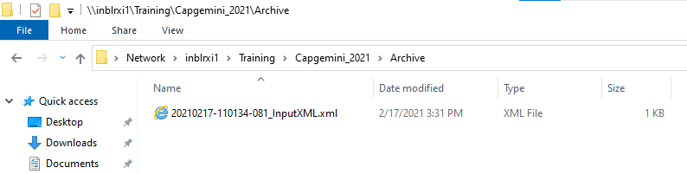

1. It is processed and converted to RFC ZDEMO_UPDATEITEMS format.

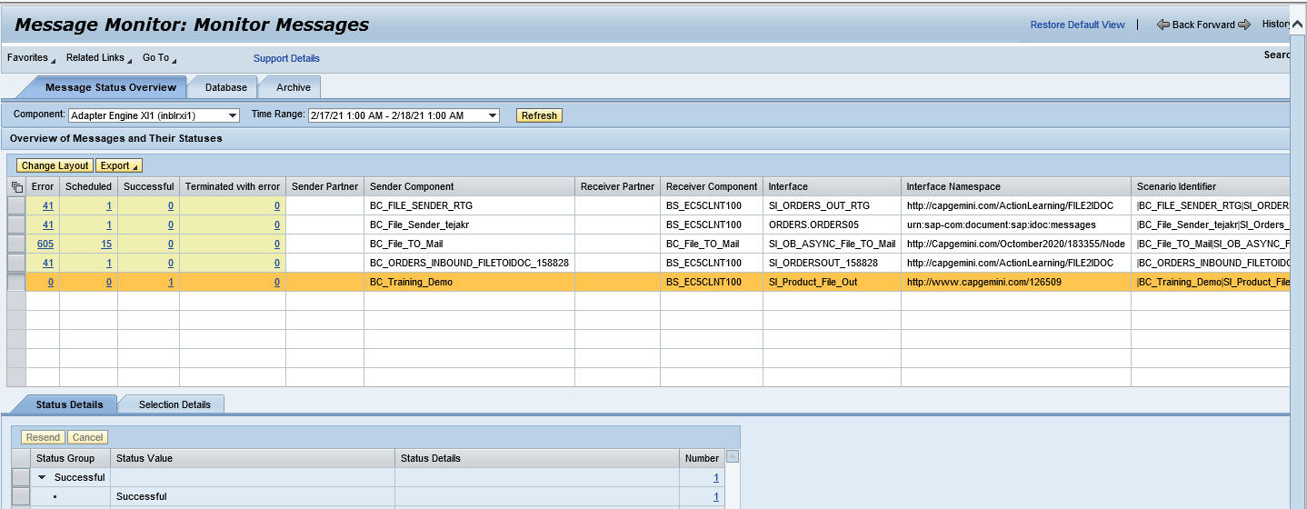

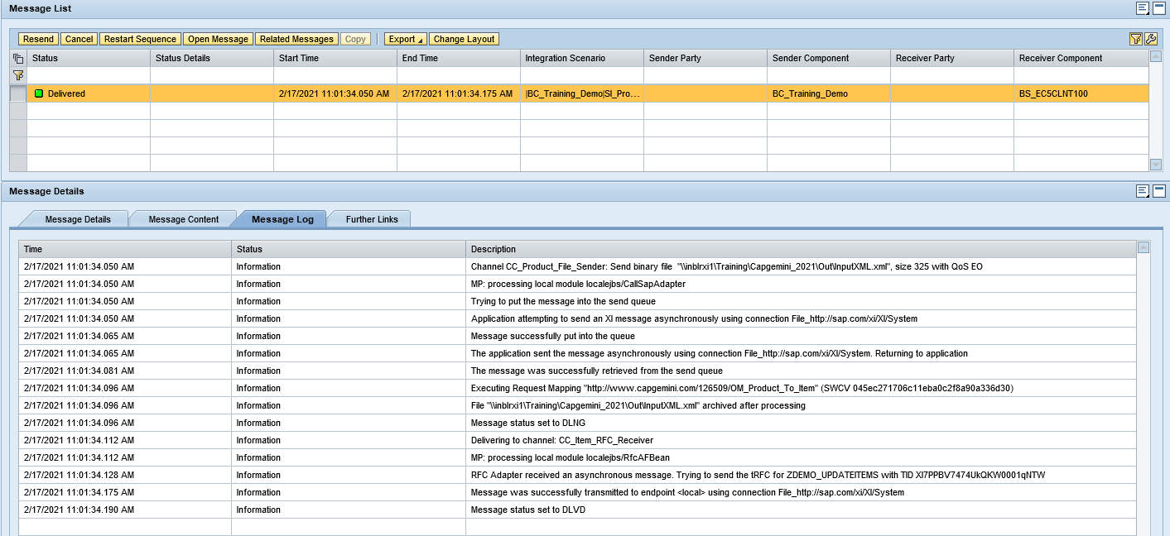

1. Table ZDEMO_ITEM is updated with corresponding data.

